Final Report
Shortlisted Team Submission Template and Guidelines
All shortlisted teams submit two items: this Final Report (PDF) and a One-Minute Video (MP4). Complete every section below using the headings provided and read the Submission Requirements at the end of this document before you start writing. Replace or delete all grey guidance text before you submit.

1. Project Information
Team Registration Number | CMAT-00114
Team Name | OATSZ
Selected Theme | 1, Water Security and Sustainable Desalination
Project Title | Reducing the Environmental Impact of Desalination Brine in the UAE Through Process Optimization and Advanced Dilution
Team Leader | Muhammad owais imran
Team Leader's Email | 23623736@student.curtin.edu.au
Team Members | Muhammad owais imran – Curtin University – cybersecurity – year 1  Simone sherry – Curtin University – Mechanical engineering – year 2  Thakshinya Prakash – Curtin University - Mechanical engineering – year 1  Armeen batool – Curtin University – Cyber security – year 2
Academic Advisor(s) | Name, title, institution, email  Benita Veronica, TITLE MISSING, Curtin University, benita.veronica@curtin.edu.au
Industry Mentor(s) | Name, position, organization, email  Puzzo Simone, position missing, Ilf engineering, simone.puzzo@ilf.com  eugenia beltran, position missing, Ilf engineering, eugenia.beltran@ilf.com
One-Minute Video Link | Shareable link, viewable without sign-in
One-Sentence Solution Statement | 25 words maximum

2. Executive Summary (thaksh)
Maximum 1 page
Summarise the problem, your solution, the key result (with numbers), the expected impact, and what you need next. Write for a non-specialist reader; judges may read this section first.
[Write your response here.]

3. Problem Definition and Context (thanks and owais)
Recommended 1–1.5 pages
Define the water challenge your team addresses. Explain who is affected, where it occurs, and how large it is, supported by cited data. Explain why current approaches are not sufficient and link the problem to the relevant SDG 6 targets.
[Write your response here.]

4. State of the Art and Gap (owais)
Recommended 1–1.5 pages
Review existing technologies, products, practices, or policies. Compare the main alternatives in a short table (performance, cost, maturity, limitations) and state clearly the gap your solution fills.

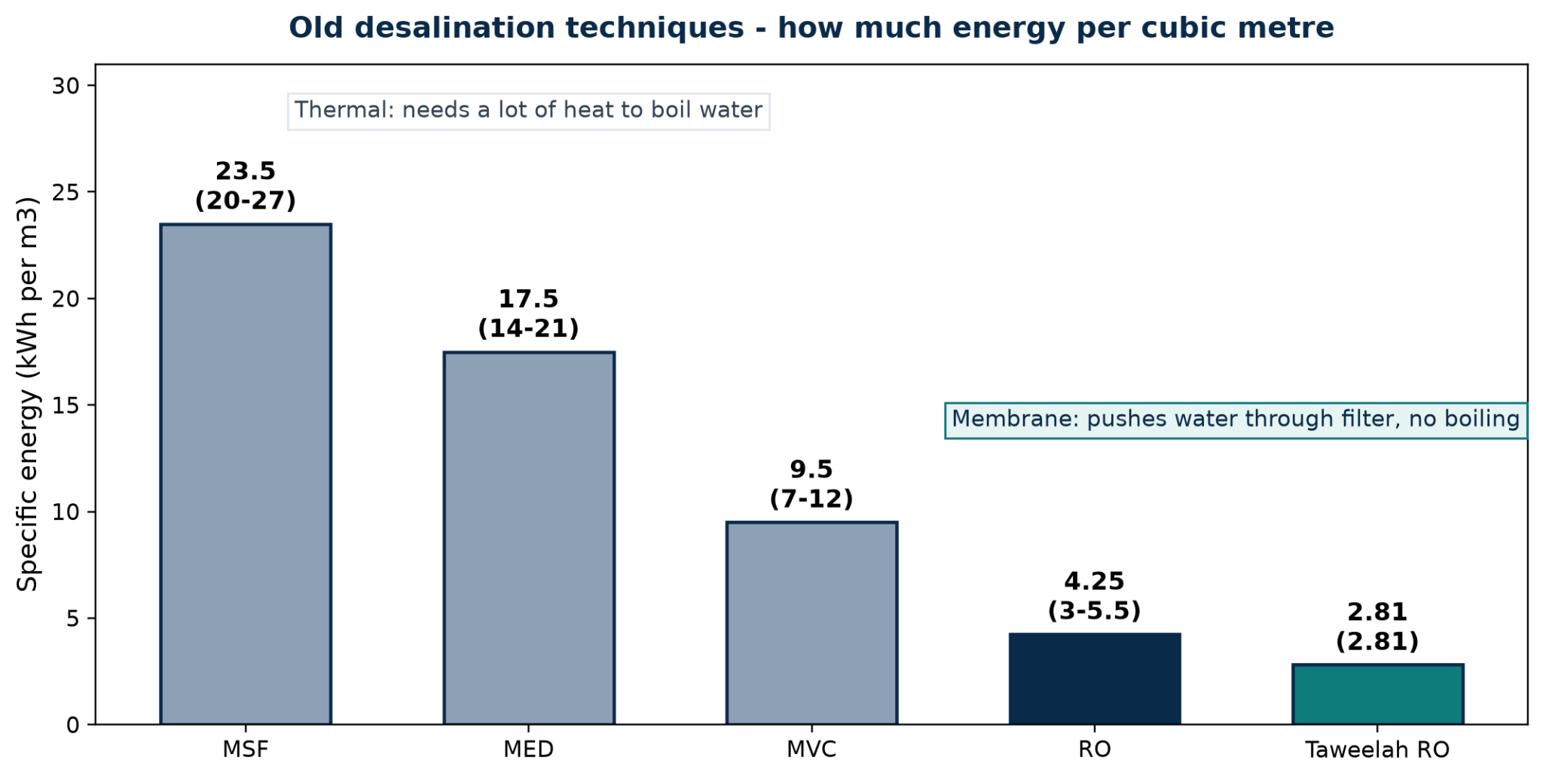
Thermal desalination ruled the Gulf through power pairing. Multi-stage flash boils seawater in stages and uses 20 to 27 kilowatt hours per cube.
Multiple-effect distillation reuses vapour in effects and uses 14 to 21. Vapour compression is best thermal at 7 to 12. All need the huge latent heat to boil water to be reused many times. They only made sense with waste steam from power stations. Membrane reverse osmosis pushes water through a filter with no boiling at 3 to 5.5, with Taweelah at 2.81 and less than half a dollar per cube. Standalone solar reverse osmosis saves energy but loses the free cooling water dilution the old paired plants gave for free.
Figure 1: Specific energy of established desalination options (kWh per m3 product water). Ranges are literature-reported context, Taweelah RO is a reported plant figure to be verified — see Section 6.
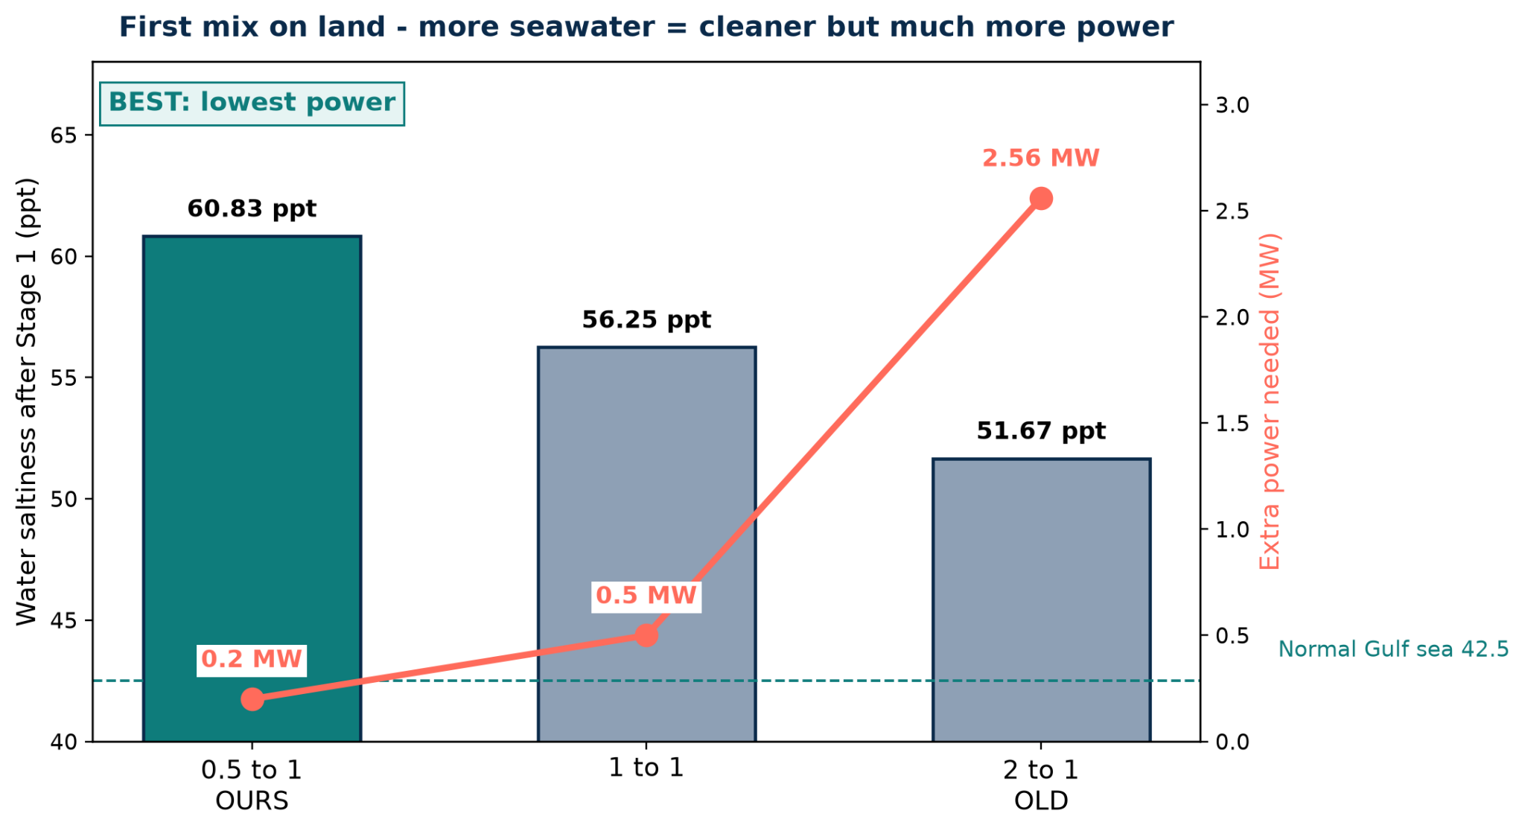
Brine mixing has two levers. Long pipes with tilted diffuser jets raise exit speed for fast near mixing. Then the sea itself spreads it, depending on depth, slope, currents and layering. Where sea grass must be protected, Spain pre-mixes: Javea holds 4 parts sea to 1 part brine to stay under 44, Alicante varied 2.5 to 7.5 and averaged 1.7 percent extra plant power. San Pedro pumps through a 4790 metre pipe plus diffuser for only 0.56 percent. Mixing follows salt balance where final salt equals brine flow times brine salt plus dilution flow times sea salt divided by total flow.
The gap is a passive retrofit that gives about 2 to 1 total dilution per power for shallow low-current water next to protected areas. Long pipes need depth, land mixing needs huge water, lone venturi needs extreme speed, boiling needs heat. MIZAN splits it: cheap 0.5 to 1 mix on land for 0.2 megawatts to 60.83, plus free underwater suck to 51.67 for 0.23 more.
Figure 2: Onshore pre-dilution trade-off for the 2-m example (CALCULATED, ESTIMATED ±30–50%). Bars = salinity after Stage 1, line = extra power. Dashed = Gulf 42.5 ppt.
Option | What it does | Energy / Cost | How mature | Problem
A. Long pipe + diffuser | Pushes brine far offshore using fast jets | Uses 0.56% of plant power | Very mature; widely used | Fails in shallow 5–12 m Gulf water; requires kilometres of piping
B. Onshore seawater dilution (2–4:1) | Dilutes brine to 44–51 ppt before discharge | 1–4% extra energy; €0.004–0.014/m³ | Very mature; used in Spain | Requires pumping over 1 million m³/day of additional water
C. Underwater Venturi alone | Uses a fast jet to entrain and mix seawater with brine | Requires 11 m/s throat velocity | Pilot stage | Can clog; discharge salinity remains around 56 ppt
D. Zero Liquid Discharge (ZLD) | Recovers 95–99% of water through intensive treatment | 7–35 kWh/m³ of brine | Industrial | Extremely high energy and heating costs
E. MIZAN 0.5–1 + eductor | Combines a static mixer with a Venturi eductor to dilute brine underwater | 0.42 MW; 0.026 kWh/m³ | Lab to pilot | Requires 7–8 m of head and screens for cleaning

5. Proposed Solution (owais)
Recommended 2–3 pages
Describe your solution and how it works, including a system or concept diagram. Explain your key design choices and what is new. If you developed a prototype, simulation model, AI tool, or digital platform, describe it here and provide an access link (repository, demo, or dataset).
[Write your response here.]

6. Methodology and Validation (owais simone)
Recommended 3–4 pages
Explain how you developed and tested the solution: experiments, simulations, models, data sources, AI training data or pilot work. State assumptions, parameters, and controls. Present results with numbered figures and tables, including uncertainty or ranges. State the current Technology Readiness Level (TRL) and the target TRL. Label any simulated or estimated results clearly.
[Write your response here.]

7. Feasibility and Scalability (armeen and thakshinya mentoring)
Recommended 1.5–2 pages
Estimate capital and operating costs (USD or AED, per m³ or per user where relevant), energy use, materials and maintenance needs. Describe the scale-up pathway from laboratory or pilot to full deployment, and list the main technical, financial and operational risks with mitigation measures.
7.1 Technical Feasibility
The MIZAN Dual-Draft Hybrid combines onshore seawater pre-dilution with an offshore passive eductor to dilute desalination brine while potentially reducing pumping requirements. The reference design assumes a brine flow of 542,851 m³/day at 70 ppt salinity, with ambient seawater at 42.5 ppt. Adding seawater onshore is estimated to reduce salinity to 60.83 ppt, followed by offshore entrainment to approximately 53.5 ppt under normal operation or 51.67 ppt under higher dilution.
These values are preliminary calculations, not experimentally verified results. Dilution redistributes salt rather than removing it, so the discharge remains more saline than ambient seawater. Feasibility depends on eductor performance, available pressure, currents, corrosion, erosion and fouling. Computational fluid dynamics (CFD) and pilot testing are required before deployment (Al-Saidi et al., 2023).
7.2 Preliminary Energy and Cost
The reference system has an estimated power demand of 0.43 MW. Assuming continuous operation and an illustrative electricity tariff of AED 0.44/kWh:
- Daily energy: 430 kW × 24 h = 10,320 kWh/day.
- Daily cost: 10,320 × AED 0.44 = AED 4,540.80.
- Annual energy: 430 kW × 8,760 h = 3.77 GWh/year.
- Annual cost: 3,766,800 kWh × AED 0.44 = AED 1.66 million.
- Energy and electricity cost per m³ of brine: 10,320 ÷ 542,851 ≈ 0.019 kWh/m³, equivalent to approximately AED 0.0084/m³ for electricity only.
These estimates exclude capital costs, maintenance, downtime and any additional booster pump. A fair comparison with conventional discharge systems must account for the same flow, dilution target and complete system costs (O’Connell et al., 2024).
7.3 UAE Case Study: Taweelah RO Plant
Taweelah in Abu Dhabi has a reported capacity of 200 million imperial gallons per day, approximately 909,200 m³/day of product water. ACWA Power reports a project cost of US$907 million and commercial operation beginning in Q1 2024. Its Environmental and Social Impact Assessment (ESIA) provides information relevant to evaluating discharge and environmental management (ACWA Power, n.d.).
Illustrative brine-flow estimate: Taweelah’s actual brine flow is not established by its product-water capacity alone. Assuming a 42% recovery rate:
Feed flow = Product flow ÷ Recovery rate
Feed flow = 909,200 ÷ 0.42 ≈ 2,164,762 m³/day.
Brine flow = Feed flow − Product flow
Brine flow = 2,164,762 − 909,200 ≈ 1.26 million m³/day.
This is an illustrative estimate, not verified plant data.
Potential MIZAN application: The existing discharge pipeline and outfall could be assessed for integration with an onshore mixing stage and offshore eductor. The plant’s actual brine flow, salinity, pipeline geometry, available pressure, bathymetry and currents must first be obtained. CFD and a site-specific pilot would then test mixing performance, pressure losses and marine plume behaviour.
Illustrative daily electricity cost at Taweelah scale:
Scale factor = Estimated Taweelah brine flow ÷ Reference brine flow
Scale factor = 1,255,562 ÷ 542,851 ≈ 2.31.
Estimated power = 0.43 MW × 2.31 ≈ 0.99 MW.
Daily cost = 0.99 MW × 1,000 × 24 h × AED 0.44/kWh ≈ AED 10,500/day.
Annual cost = AED 10,500 × 365 ≈ AED 3.83 million/year.
This assumes linear scaling and continuous operation. It is not Taweelah’s actual operating cost; real performance and costs require plant-specific engineering data and testing.
7.4 Costs, Scalability and Risk Management
Capital costs include the eductor, pipeline modifications, seawater intake and screens, instrumentation, marine installation, modelling and environmental approvals. Duplex stainless steel and other seawater-resistant materials could be evaluated for corrosion and erosion resistance. A reliable capital-cost estimate requires final design specifications and supplier quotations.
Implementation should proceed in stages: (1) CFD and hydraulic modelling; (2) laboratory testing of entrainment, pressure and energy use; (3) a site-specific pilot; and (4) independent environmental and economic evaluation before any full-scale decision.
Key risks include insufficient entrainment, higher-than-expected energy demand, corrosion, fouling, intake impacts on marine organisms and unacceptable salinity plumes. Mitigations include testing under realistic conditions, routine inspection, suitable materials, intake protection and monitoring salinity at multiple distances from the outfall. Site-specific ecological assessment is particularly important in the Persian Gulf (Sharifinia et al., 2019).
Routine maintenance would include cleaning intake screens, inspecting the eductor and pipelines for corrosion or erosion, calibrating sensors and replacing worn components.
7.5 Feasibility Conclusion
MIZAN offers a potentially scalable method of improving initial brine mixing, with preliminary reference energy costs of approximately AED 4,541/day. A simplified Taweelah scale-up suggests approximately AED 10,500/day, based on an assumed recovery rate and linear scaling. Neither estimate is experimentally verified. Further modelling, pilot testing, verified plant data and lifecycle-cost analysis are necessary before claiming economic savings or environmental compliance.

8. UN-Aligned Impact and Policy Brief (armeen)
Recommended 1.5–2 pages
Explain how the solution contributes to the UN Water pillars and SDG 6, and to any related goals (e.g., SDG 3, 7, 11, 13, 14). Describe the expected environmental, social, health, and economic benefits with measurable indicators. Provide policy or governance recommendations that would support adoption.

9. Industry-Adoption Roadmap (simon e owais)
Recommended 1–1.5 pages
Identify target users, customers and partners, and the business or delivery model. Outline regulatory, certification, or approval steps, and present a milestone timeline for the next 12–36 months.

10. Team Contributions, Mentoring and Ethics (thanks )
Recommended 0.5 page
State each member’s contribution and the input received from your academic advisor and industry mentor. Note any ethics, safety or data-protection approvals, and disclose where and how generative AI tools were used.
[Write your response here.]

11. Conclusions and Next Steps (whole team and takshno)
Recommended 0.5 page
Summarise the main findings and the limitations of your work, and explain how you would develop the solution further, including how prize funding and mentoring would be used.
[Write your response here.]

12. References (everyone)
Section 7:
ACWA Power. (n.d.). Taweelah RO desalination IWP. https://acwapower.com/en/what-we-do/projects/taweelah-ro-desalination-iwp/
ACWA Power. (2019). Taweelah IWP environmental and social impact assessment: Volume 2. https://acwapower.com/media/kudjbtxa/al-taweelah-iwp-esia-volume-2.pdf
Al-Saidi, M., Saadaoui, I., & Ben-Hamadou, R. (2023). Governing desalination, managing the brine: A review and systematization of regulatory and socio-technical issues. Water Resources and Industry, 30, 100225. https://doi.org/10.1016/j.wri.2023.100225
O’Connell, M. G., et al. (2024). Analysis of energy, water, land and cost implications of zero and minimal liquid discharge desalination technologies. Nature Water, 2, 1116–1127. https://doi.org/10.1038/s44221-024-00327-1
Sharifinia, M., et al. (2019). Prevention is better than cure: Persian Gulf biodiversity vulnerability to the impacts of desalination plants. Global Change Biology, 25(12), 4022–4033. https://doi.org/10.1111/gcb.14808

13. Appendices (Optional)
Maximum 10 pages · not counted in the page limit
Include supporting material only: additional data, detailed calculations, code or model documentation, and letters of support. Judges are not required to read the appendices, so keep all essential content in the main report.
null

14. Team Leader and Academic Advisor Declaration
We confirm that the information in this Final Report and the One-Minute Video is accurate and is the original work of the team; that all sources, data and tools, including any generative AI tools, have been acknowledged; that everyone appearing in the video has consented to its publication; and that the academic advisor has reviewed this submission.
Team Leader's Name: Muhammad owais imran
Signature: Signed owais imran
Date: 30/10/2026
Academic Advisor's Name:
Signature:
Date:

Submission Requirements
Read these requirements carefully. Submissions that are late, incomplete or exceed the hard limits below may not be evaluated.

A. Key Dates
Milestone | Date | Details
Final Report and One-Minute Video due | 1 November 2026, 23:59 (UAE time, GMT+4) | Both items submitted together by the team leader
Finalists announced | 6 November 2026 | Finalist teams are notified by email
Finals and awards ceremony | 8–10 December 2026 | On-site showcasing in Abu Dhabi during the UN Water Conference

B. Final Report Format
Element | Requirement
Length | Maximum 15 pages for Sections 2–11. Project Information, References, Appendices and Declaration are not counted. Pages beyond the limit will not be read.
Page layout | A4, portrait, 2.5 cm margins; use this template without changing its headings or order
Font and spacing | Calibri 11 pt body text, 1.15 line spacing; headings as provided in this template
Language | English, with consistent spelling throughout
Figures and tables | Numbered and captioned (Figure 1, Table 1), legible when printed, and cited when not your own
Units and equations | SI units; equations numbered with all symbols defined at first use
Headers and footers | Keep the hackathon header; add page numbers in the footer
File format | One text-searchable PDF (not scanned), fonts embedded, maximum 10 MB

C. One-Minute Video Requirements
Element | Requirement
Duration | Maximum 60 seconds, including titles and credits. Content after 1:00 will not be considered.
Technical format | MP4 (H.264), 1920 × 1080 pixels, 16:9 landscape, maximum 100 MB
Language and subtitles | English narration or English subtitles; burned-in English subtitles are required so the video can be understood without sound
Opening and closing | Open with a title card (project title, team registration number, theme); close with team name, universities and credits
Team presence | At least one team member must appear on camera or narrate
Content and rights | Original footage, animations or screen recordings only; any music or images must be royalty-free or licensed and credited
Logos and consent | Do not use Khalifa University, UNESCO or UN logos unless provided by the organizers. Everyone shown must consent to publication.
Use of the video | The video may be screened at the finals and shared on organizer channels

Recommended storyboard
Time | Segment | What to show
0:00–0:05 | Title and hook | Title card and one striking fact about the problem
0:05–0:15 | The problem | Who is affected, where, and how much – one key number
0:15–0:35 | The solution | What it is and how it works: prototype, model, app demonstration or animation
0:35–0:48 | The evidence | Your key result and how it compares with current options
0:48–0:56 | Impact and scale | Contribution to SDG 6 and the UN Water pillars; who will adopt it next
0:56–1:00 | Close | Team name, universities, call to action and credits

D. Evaluation Criteria
The Final Report and One-Minute Video are evaluated together by the technical review panels, the UN/policy relevance panel and the grand jury, using the official hackathon criteria:
Criterion | Weight | Main evidence
Scientific and technical rigor | 30% | Sections 4–6
Alignment with UN Water pillars | 20% | Section 8 and the video
Feasibility and scalability | 20% | Section 7
Industry relevance and adoption potential | 15% | Section 9
Quality of communication and presentation | 15% | Whole report and the video

E. How to Submit
- Submit the Final Report as a PDF and include the One-Minute Video through the Google Form.
- Make sure the uploaded video file (MP4) can be viewed and keep it available until 31 December 2026.
- Deadline is 1 November 2026, 23:59 (UAE time). The last submission received before the deadline will be evaluated.
Name the files as follows:
Registration Number_Theme Number_Team Leader Name_Final Report.pdf
Registration Number_Theme Number_Team Leader Name_Video.mp4

F. Final Checklist
☐ All sections (1–14) are completed using the template headings, and all grey guidance text is removed.
☐ Sections 2–11 do not exceed 15 pages; appendices do not exceed 10 pages.
☐ Team registration number, all team members, academic advisor, and industry mentor are listed.
☐ Figures and tables are numbered, captioned and cited; all sources are referenced.
☐ The report is a searchable PDF under 10 MB and named correctly.
☐ The video is 60 seconds or less, MP4 1080p, under 100 MB, with English subtitles.
☐ The video link opens without sign-in, and the report and video use the same title and key figures.
☐ Use of generative AI tools is disclosed in Section 10.
☐ The declaration is signed by the team leader and the academic advisor.

